

CAPSTONE PROJECT REPORT
Report 5 – Software Test Documentation

– Hanoi, Fall 2025 –
Table of Contents
I. Record of Changes 3
II. Testing Documentation 4
1. Scope of Testing 4
1.1. Testing Targets 4
1.2. Testing Levels 7
2. Test Strategy 7
2.1 Testing Types 7
2.2 Test Level 8
2.3 Supporting Tools 8
3. Test Plan 9
3.1 Human Resources 9
3.2 Test Environment 9
3.3 Test Milestones 9
4. Test Cases 10
4.1 Unit Test 10
4.2. Integration Test 11
4.3. System Test 12
4.4 Acceptance Test 13
5. Test Reports 13
5.1 Unit Test 14
5.2. Integration Test 16
5.3. System Test 16
5.4 Acceptance Test 17

I. Record of Changes
Date | A*  M, D | In charge | Change Description
23/11/2025 | A | DuongNT17 | Added 1. Scope of Testings
23/11/2025 | A | DatVV | Added 2. Test Strategy
23/11/2025 | A | DuongNT18 | Added 3. Test Plan
30/11/2025 | A | DuongNT17 | Added 4. Test Cases
1/12/2025 | A | DuongNT18 | Added 5. Test Reports
5/12/2025 | M | DuongNT17 | Modified 4. Test Cases
6/12/2025 | M | DuongNT18 | Modified 5. Test Reports
*A - Added M - Modified D - Deleted

II. Testing Documentation

1. Scope of Testing

1.1. Testing Targets

1.1.1. Feature, Functional
The scope of testing includes all functional modules defined in [SEP490_G127_Report3_Software Requirement Specification]

1.1.2. Non - Functional

1.1.2.1. User Interface
Aspect | Admin Interface | Sales Staff Interface
Performance | Interface Design: Clear hierarchical menu for managing product, warehouse, orders, users, reporting. Dashboard displays charts and stats for quick decision-making.  Visual Style: ≤ 3 seconds for operations such as product search, updating inventory, applying discounts. | Performance Requirement:Fast product loading and optimized checkout experience for sales staff at counter or POS.  Response Time Standard: ≤ 3 seconds for scanning products, adding to cart, processing payments.
Usability | Usability Criteria: Clear, structured workflows, dashboards, and management screens.  Ease of Learning: Guided by charts, sidebar navigation, tooltips. | Usability Criteria: Quick and intuitive checkout flow requiring minimal training.  Ease of Learning: Optimized POS workflow for speed (scan → add → pay).
Reliability | Reliability: Stable data operations and accurate reporting.  Fault Tolerance: Auto-save & rollback for critical operations. | Reliability: Smooth checkout and payment flow without interruptions.  Fault Tolerance: Clear retry options during payment or scanning.
Accessibility | Accessibility: Keyboard navigation, chart descriptions, tooltips.. | Accessibility:Support POS terminals, tablets; large button layout for fast interaction.
Security | RBAC, encrypted operations, admin login rules. | Secured transaction flow, limited permissions for staff accounts.
Scalability | Scalability: Add more stores, modules, reporting dashboards.without affecting performance.  Ease of Upgrades: Supports scaling to manage large volumes of management data when necessary. | Scalability: Handle high checkout volume during peak hours.  Ease of Upgrades: Allows for the addition of new features or updates to the customer interface.
Engagement & Adaptability | Interactivity: SnapBuy provides an intuitive dashboard for administrators | Interactivity: SnapBuy provides an optimized checkout interface for sales staff, designed for quick product lookup and payment processing.

1.1.2.2. Software and Hardware Interfaces
Aspect | Software Interfaces | Hardware Interfaces
Performance | - API latency < 2s, efficient DB queries, concurrency support. | - Barcode scanners, receipt printers respond within 2s.
Usability | - Clear feedback, guided error messages. | - Simple setup, status indicators for errors.
Reliability | - Failover support, retry logic, backup system. | -Hardware redundancy and auto diagnostic.
Security | - TLS encryption, RBAC, audit logs. | - Restricted physical access; authenticated device communication.
Scalability | - Supports new modules, APIs, and scaling DB. | - Allow adding more scanners, printers, POS terminals.
Interoperability | - Works with external APIs, supports multiple OS & browsers. | - Compatible with POS systems, standard protocols (USB/Wi-Fi).
Maintainability | - Modular architecture, documented updates. | - Easy hardware replacement, firmware updates.
Monitoring and Logging | - Full logs for API, DB, user actions. | - Hardware performance monitoring.
Error Handling | - Friendly error messages; auto-logging. | - Auto alerts for malfunctions.
Compliance | - GDPR, cybersecurity standards. | - Electrical safety, RoHS compliance.
Power Efficiency | - Optimized resource usage. | - Low-power modes for POS devices.
Environmental Tolerance | - Stable under varying loads. | - Works under conditions like humidity/dust (warehouse).

1.1.2.3. Usability and Security Requirements
- Consistency: Uniform layout for POS pages, admin pages, and dashboards.
- Intuitiveness: Logical workflows, clear actions for POS checkout.
- Accessibility: WCAG 2.1 AA compliance: keyboard navigation, screen reader support.
- Responsiveness: Fully responsive on PC, tablet, and POS device screens.
- Feedback: Success/error messages and loading indicators for long operations.
- Help & Documentation: Built-in tooltips and online user guide.
- Error Prevention & Recovery: Input validation, warnings, and undo options.

1.1.2.4. Security Requirements
- Authentication and Authorization:
- The system should implement strong user authentication mechanisms, including multi-factor authentication (MFA).
- Role-based access control (RBAC) should be enforced to ensure users only have access to necessary functions and data.
- Data Encryption:
- All sensitive data should be encrypted in transit using TLS and at rest using industry-standard encryption algorithms.
- Encryption keys should be managed securely and rotated periodically.
- Data Integrity:
- The system should include mechanisms to ensure data integrity, such as checksums and hashing.
- Regular data integrity checks should be performed to detect and address any corruption.
- Audit Logging:
- The system should maintain comprehensive audit logs for all user actions, especially those involving sensitive data or administrative functions.
- Logs should be protected from tampering and retained for a specified period as per regulatory requirements.
- Incident Response:
- A formal incident response plan should be in place, including procedures for detecting, reporting, and responding to security incidents.
- Users should be notified promptly of any data breaches that may affect them.
- Data Privacy:
- The system should comply with relevant data privacy regulations such as GDPR, ensuring users' personal data is handled responsibly.
- Users should have control over their data, including the ability to view, update, and delete their personal information.
- Regular Security Assessments:
- The system should undergo regular security assessments, including vulnerability scans, penetration testing, and code reviews.
- Identified vulnerabilities should be addressed promptly to maintain a secure environment.
- Secure Development Practices:
- Secure coding practices should be followed to prevent common vulnerabilities such as SQL injection, XSS, and CSRF.
- Automated tools should be used to check for security issues during development.
- Access Control:
- Strict access controls should be implemented for administrative interfaces, with access granted only to authorized personnel.
- All-access attempts, successful or failed, should be logged and monitored.
- User Education:
- Users should be educated on security best practices, such as recognizing phishing attempts and creating strong passwords.
- Regular security awareness training should be conducted for all users.

1.2. Testing Levels
- We have 4 levels of testing: Unit Test, Integration Test, System Test, Acceptance test
No | Test level | In charge | Time | Focuses | Acceptance criteria
1 | Unit Test | Developers | During implementation | Validate behavior of each unit (service, controller, repository). | All branches covered, no unexpected exceptions.
2 | Integration Test | Testers | After UT passes | Validate interactions: Controller → Service → Repository → DB. | Data flow is correct, modules integrate successfully.
3 | System Test | Testers | After IT | Validate logic flows, performance, UI, security. | The full system works as designed.
4 | Acceptance Test | End-Users | After System Test | Confirm business requirements are met using real data. | User confirms system readiness for production.
Table 1.1. Testing Levels

2. Test Strategy

2.1 Testing Types
- The test team has to test the following type on Postman, Google Chrome browser, Edge browser:
- Unit Testing
- Integration Testing
- System Testing
- User Acceptance Testing

Type of Testing | Objective | Technique | Completion Criteria
Unit Testing | Verify that each smallest component functions correctly and meets requirements | White-Box Testing techniques, such as Condition Testing and Control Flow Testing | Complete when all units have been independently tested, have no critical errors, and inputs/outputs meet expected results
Integration Testing | Ensure modules or units interact and function correctly when integrated | Bottom-Up or Top-Down Integration | Complete when all integrated modules work correctly together, with no interaction or integration errors
System Testing | Test the entire system to ensure all components function correctly and meet requirements | Black-Box Testing, including comprehensive testing of functionality, performance, and security | Complete when all functional requirements are successfully tested, and the system has no critical defects
User Acceptance Testing | Ensure the system meets user requirements and expectations | Black-Box Testing based on real user scenarios | Complete when users accept the system after all UAT scenarios pass successfully with no critical defects
Table 2.1.Description of testing types

2.2 Test Level
Type of Tests | Test Level
Type of Tests | Unit | Integration | System | Acceptance
Unit Testing | X | X | X
Integration Testing |  | X | X | X
System Testing |  |  | X | X
Acceptance Testing |  |  | X | X

2.3 Supporting Tools
Purpose | Tool | Vendor/In-house | Version
Manage test case and data index | Microsoft Excel Online | Microsoft
Manage bugs and status of fixed | Microsoft Excel Online, GitHub issue | Atlassian
The interface to test | Microsoft Edge browser, Chrome

3. Test Plan

3.1 Human Resources
Worker/Doer | Role | Specific Responsibilities/Comments
DuongNT17 | Test Lead | - Create test cases and perform unit tests.  - Create test cases and perform integration tests.  - Create test cases and perform system tests.  - Create test cases, checklists and perform acceptance tests.  - Summaries test reports.
DuongNT18  DatVV  DuongNT17 | Team member | Fix bugs front-end
HuyNX  NamNV | Team member | Fix bugs back-end
HuyNX  NamNV  DuongNT18  DatVV  DuongNT17 | Team member | Review Test Plan.  Execute Test (IT, ST)  Review Test Report.
Table 3.1. Human Resources

3.2 Test Environment
Purpose | Tool | Provider | Version
Write unit test documents | Excel | Microsoft | Latest
Write test report documents | Excel | Microsoft | Latest
Run UT (Units Test) | Postman | Postman | Latest
Run IT (Integration Test) | Postman | Postman | Latest
Tracking defects, issues and Q&A | Excel, GitHub issues | Microsoft, GitHub | Latest
Table 2.4. Test Environment

3.3 Test Milestones
Milestone Task | Start Date | End Date
Create test plan | 30/09/2025 | 04/10/2025
Create UT test cases | 05/10/2025 | 08/10/2025
Create IT test cases | 09/10/2025 | 12/10/2025
Create UAT test cases | 13/10/2025 | 16/10/2025
Create ST test cases | 17/10/2025 | 20/10/2025
Create, update and execute UT test cases | 21/10/2025 | 27/10/2025
Create, update and execute IT test cases | 28/10/2025 | 03/11/2025
Create, update and execute ST test cases | 04/11/2025 | 08/11/2025
Create, update and execute UAT test cases | 09/11/2025 | 13/11/2025
Full system testing | 14/11/2025 | 18/11/2025
Create Test Report | 19/11/2025 | 22/11/2025
Table 3.5. Test Milestones

4. Test Cases

4.1 Unit Test
Functional testing will be done on the server development side by the backend developer:
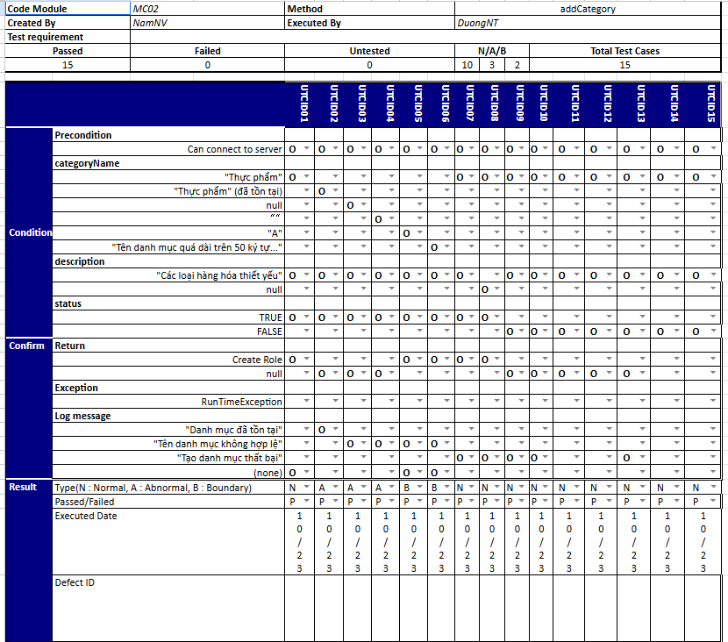
Figure 2.1. Unit Test Case Test

4.2. Integration Test
- Integration testing will involve incorporating the API into the app's interface to assess the data representation for the user. The tester will select test cases from the Test Report wherein actions are performed between functions or data is exchanged between modules. Subsequently,The user will utilize Postman to test the input-output data. If any errors occur during testing, specifically concerning unexpected data, testers will log defects or bugs on Jira and track the failed test case until it is addressed and resolved by developers.
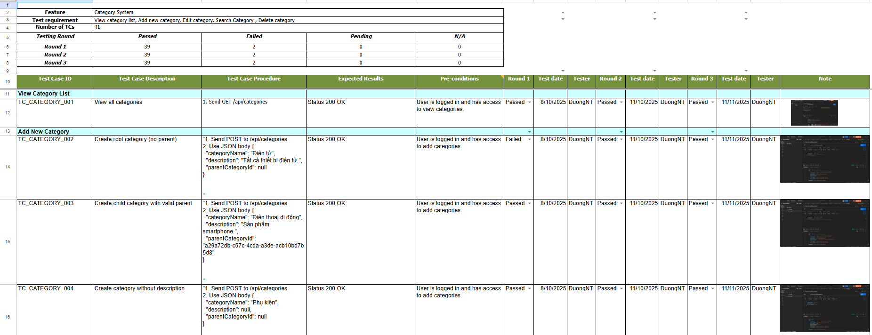
Figure 2.2. Integration test

4.3. System Test
- This testing stage occurs after the functions outlined in the requirements have been completely implemented. We will conduct tests using the new system version. The primary objective of this test phase is to evaluate the performance of the application when operated by the user on the device, assessing how the user interacts with the application under different scenarios.
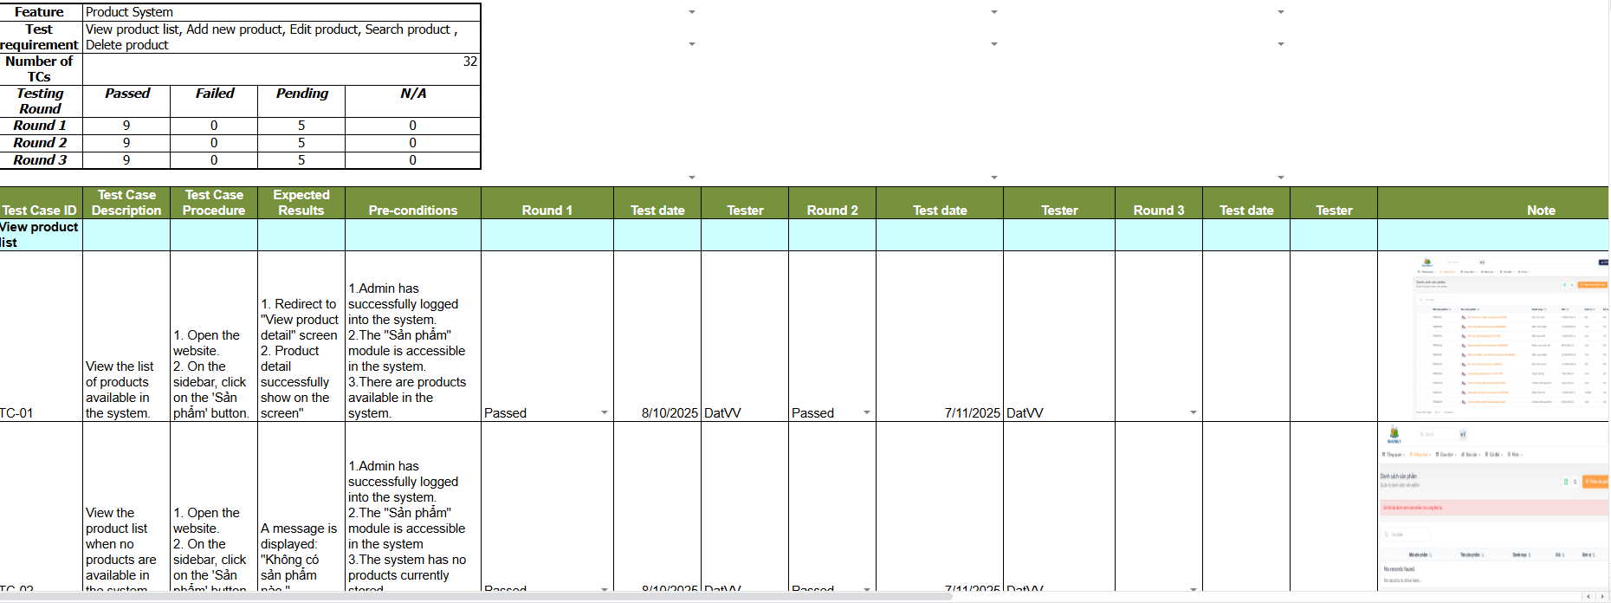
Figure 2.3. System test

4.4 Acceptance Test
- This testing stage is conducted after all system functions defined in the requirements have been fully implemented. The tests are performed on the final version of the system to verify that the application satisfies user requirements and acceptance criteria. The main purpose of Acceptance Testing is to evaluate the system from the user’s perspective by observing how users interact with the application on their devices under different usage scenarios, ensuring the system is ready for deployment and use.
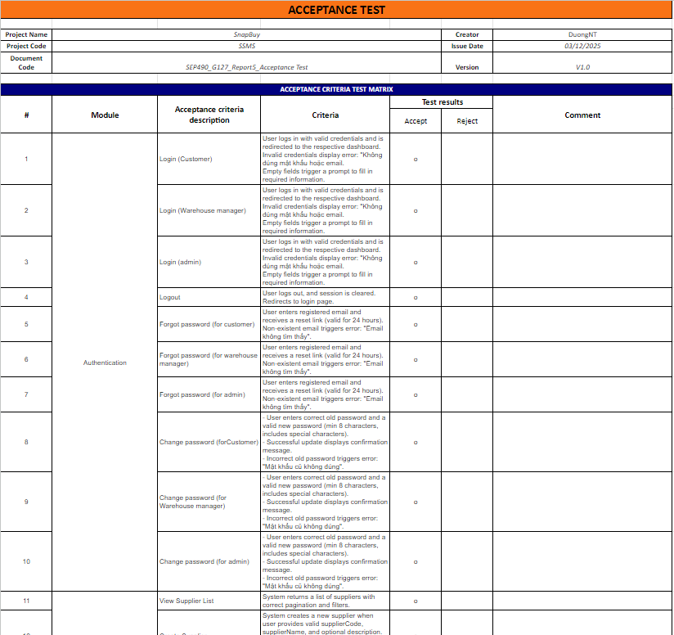
Figure 2.4. Acceptance Test

5. Test Reports
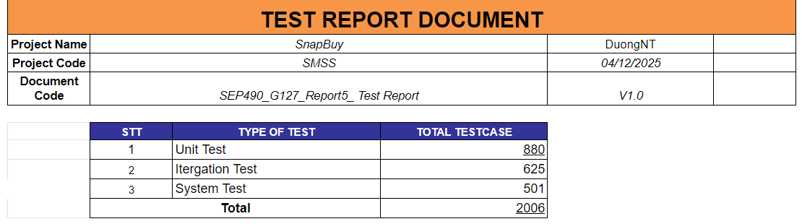
Figure 2.5. Total testcase

5.1 Unit Test
[5.1 Unit Test]
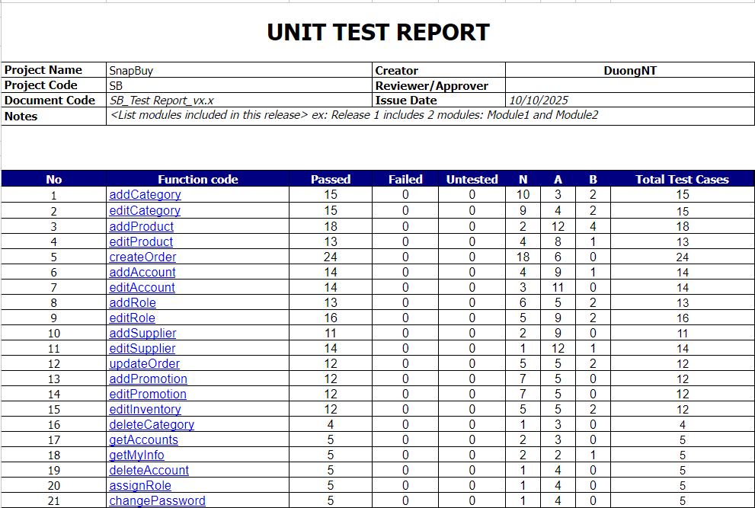
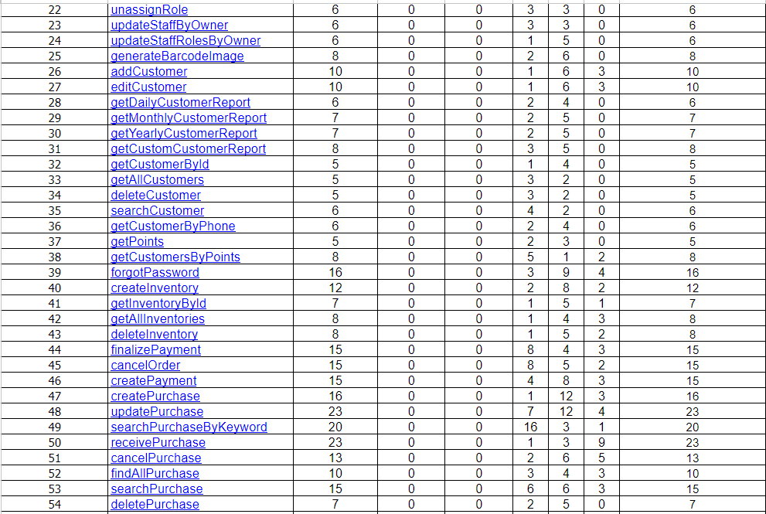
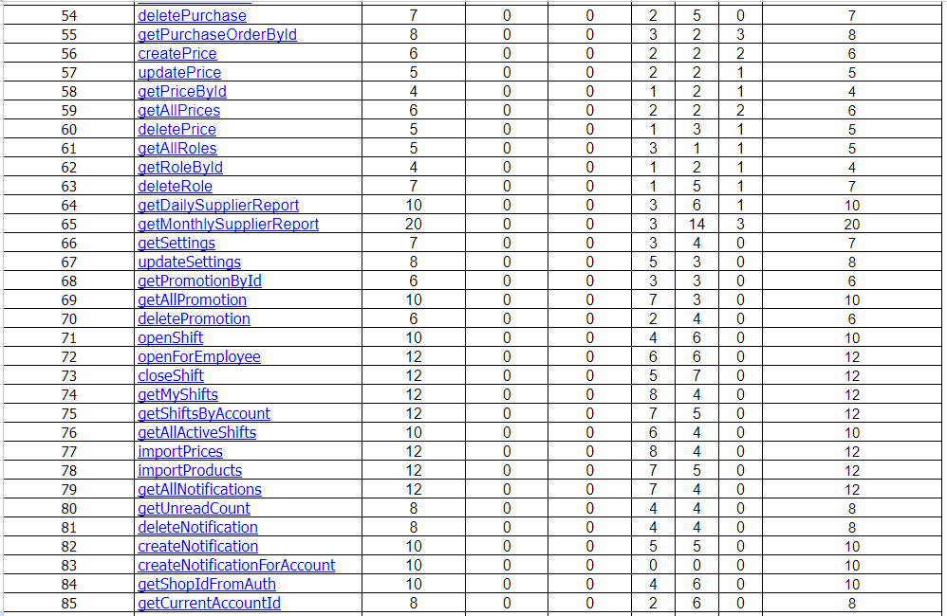

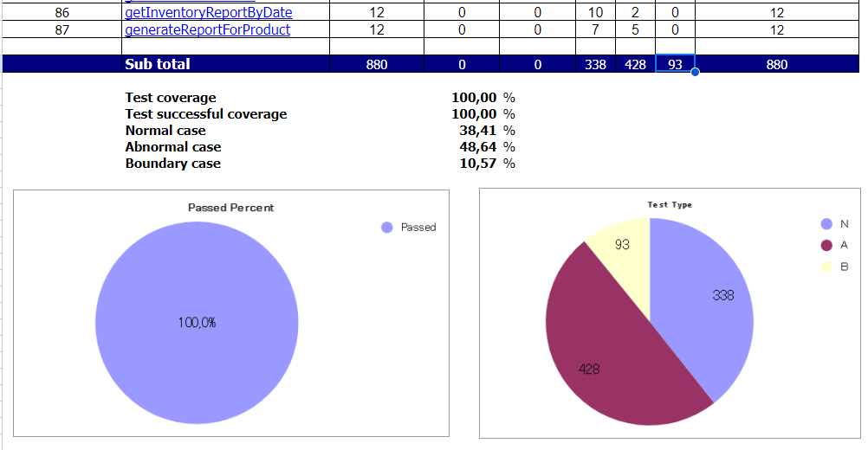
Figure 2.6. Unit Test Case Test

5.2. Integration Test
[5.2 Integration Test]
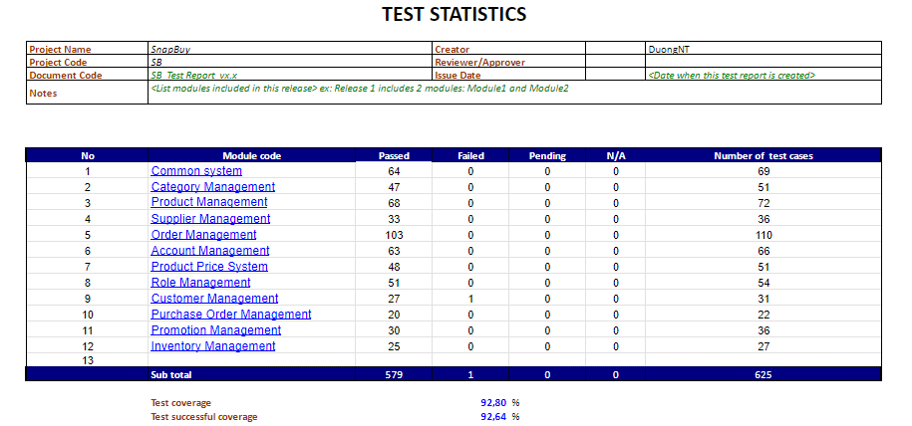
Figure 2.7. Integration test

5.3. System Test
[5.3 System Test]
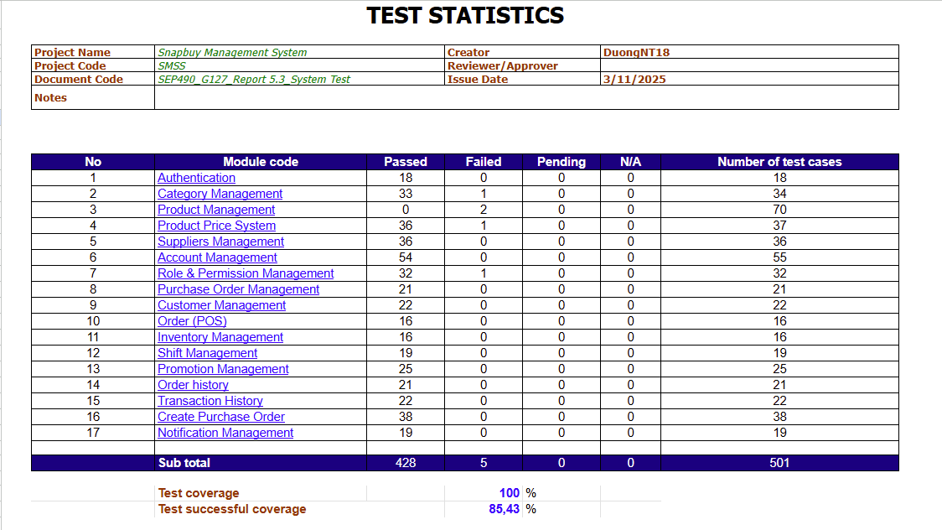
Figure 2.8. System test

5.4 Acceptance Test
[5.4 Acceptance Test]
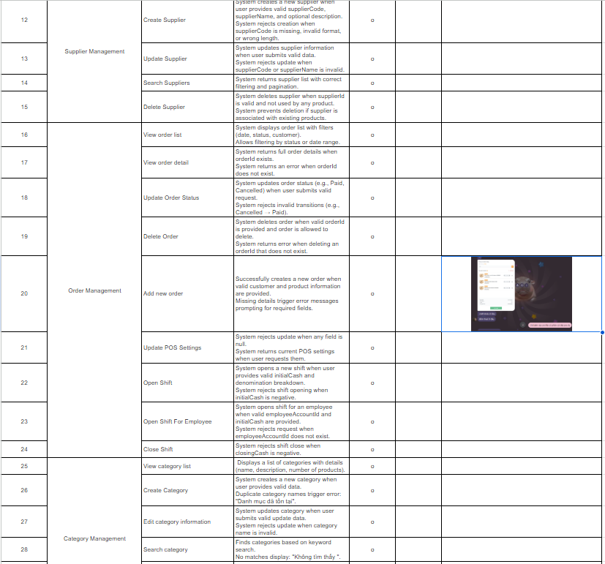

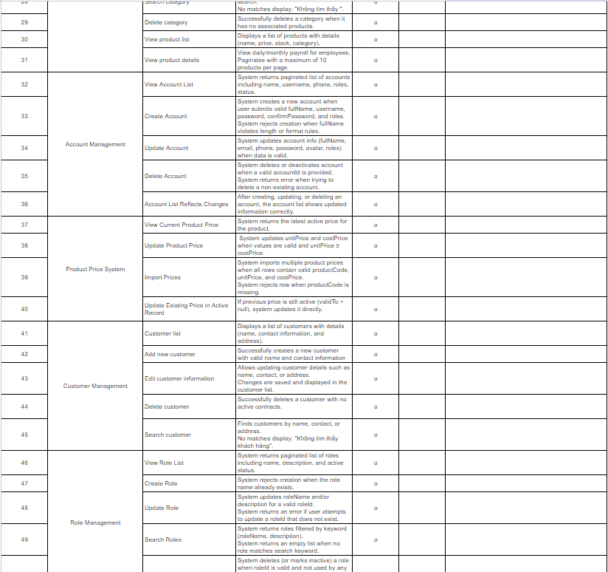

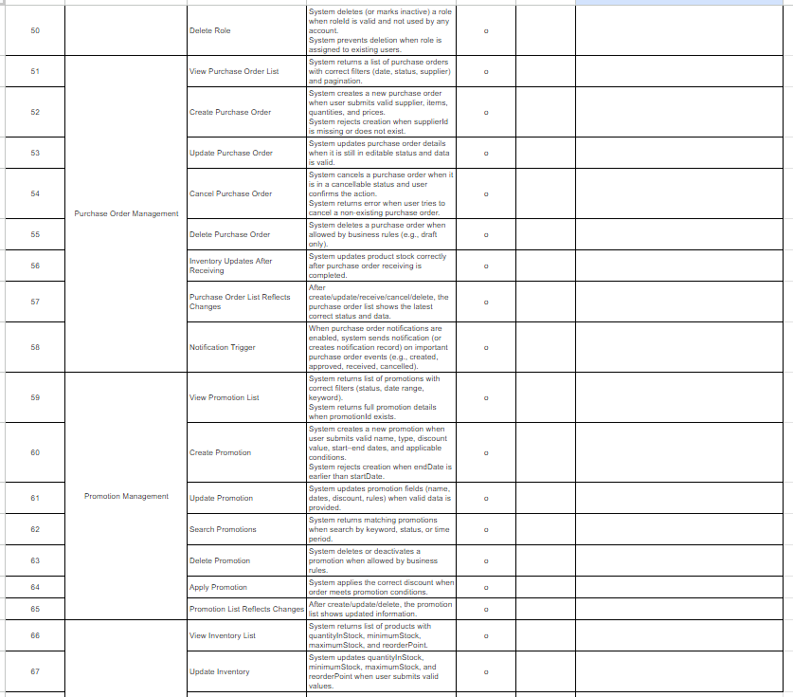

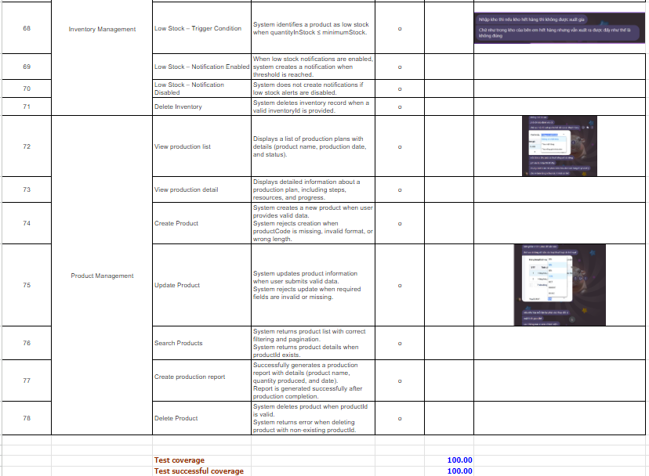
Figure 2.9. Acceptance Test

